Project Design Phase-I
Solution Architecture

Date | 24 October 2026
Team ID | [Enter Team ID]
Project Name | Electric Vehicle Market Performance & Insights
Maximum Marks | 4 Marks

Solution Architecture:
Solution architecture is a complex process – with many sub-processes – that bridges the gap between business problems and technology solutions. Its goals are to:
- Find the best tech solution to solve existing business problems.
- Describe the structure, characteristics, behavior, and other aspects of the software to project stakeholders.
- Define features, development phases, and solution requirements.
- Provide specifications according to which the solution is defined, managed, and delivered.

Solution Architecture Diagram – EV Market Performance & Insights:
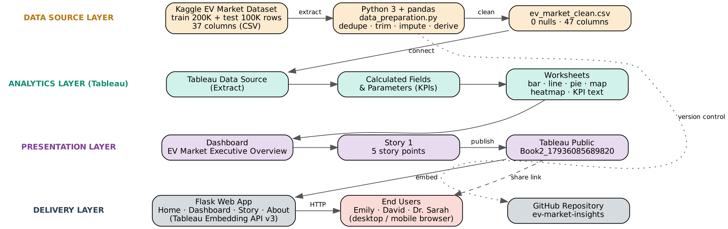

The solution follows a four-layer flow: the raw Kaggle CSVs are cleaned in Python, analysed in Tableau through calculated KPIs and worksheets, presented as a dashboard and story on Tableau Public, and delivered to users through a direct link or the Flask web app.

Component Description Table
Component Name | Description / Role in Architecture | Technology Used
Data Source | Kaggle EV Market Classification Dataset – train (200,000 rows) and test (100,000 rows) CSVs with 37 attributes. | CSV files (Kaggle)
Data Preparation | Removes duplicates, trims text, imputes nulls with group medians, derives segment/price/range/rating bands and ratios; outputs ev_market_clean.csv. | Python 3, pandas, NumPy (data_preparation.py)
Data Storage / Data Source Layer | Holds cleaned data for fast analysis; geographic role and default aggregations configured. | CSV + Tableau Extract (.hyper)
Business Logic (KPIs) | Total Annual Sales, Market Share %, Avg Customer Rating, Avg Range, % of Total Annual Sales, Top-10 manufacturers. | Tableau calculated fields, table calculations, filters
Visualization Layer | Category sales bar, Top-10 bar, KPI text, battery pie, range bars, trend line, country map, rating heatmap. | Tableau Public Desktop
Dashboard & Story | 'EV Market Executive Overview' dashboard with filters/legends; Story 1 with 5 captioned story points. | Tableau Dashboard & Story
Publishing | Hosts the interactive workbook online (Book2_17936085689820). | Tableau Public
Web Application | Home, Dashboard, Story and About pages embedding the published views. | Flask, Jinja2, HTML/CSS, Tableau Embedding API v3
Version Control & Docs | Source code, build guide, documentation and demo script. | Git, GitHub

